NATIONAL AND KAPODISTRIAN UNIVERSITY OF ATHENS
  - Accessibility Unit for Students with Disabilities
Phone numbers: +30 210 7275687, +30 210 7275130
Fax: +30 210 7275193
E-mail: access@uoa.gr
Website: https://access.uoa.gr
Students with Disabilities (SwD) who enter Greek Universities are either:
- those who have been entered university by law regulations,
- those admitted by regular special national examinations, or
- those who acquired their disability during their studies.
The basic requirements of the students with disabilities include:
- access to interpersonal communication with the members of the academic community,
- access to the built environment of the university,
- access to the printed or electronic educational material,
- access to the blackboard and the presentations in the classrooms,
- access in keeping notes, lesson and lab projects, and written examinations, and
- access in information, Internet content and Information and Technology applications.
The mission of the AUSD is to actively realize coequal access to academic studies for students with different abilities and needs, through built environmental modifications, Assistive Technologies and access services.

Infrastructure of the Accessibility Unit
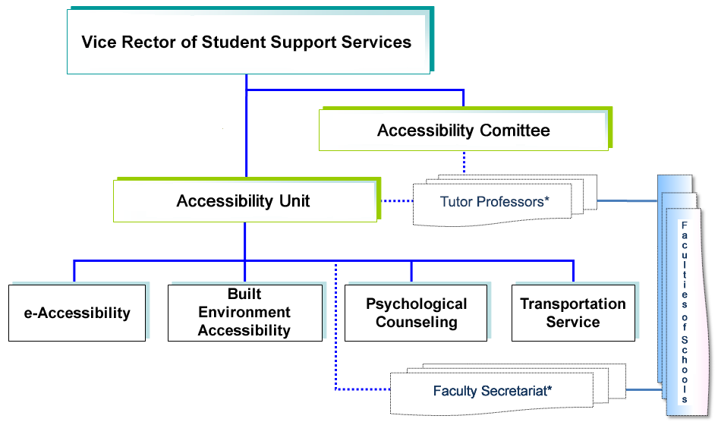
Tutor Professors: A tutor-Professor (and his/her Deputy) has been appointed in each Academic Department of the National and Kapodistrian University of Athens in order to support Students with Disabilities during their studies.
Faculty Secretariat: A Person in Charge for Students with Disabilities (and his/her Deputy) has been appointed in each Academic Department Secretariat of the National and Kapodistrian University of Athens.

Department of Electronic Accessibility
Information and Communication Technologies can, in many cases, provide solutions to the requirements and meet the needs of Students with Disabilities (SwD). Many times these solutions are the only way for SwD to be able to attend University their studies and then work professionally. Some of the main activities of the Department of Electronic Accessibility of the University of Athens are:

Recording the Needs of Students with Disabilities
Is performed in systematic way using a special form which can be requested, filled in and submitted to the Secretariat of her/his Department in alternative.

Assessment of SwD abilities
The specific needs and potential problems encountered during the SwD academic studies are identified based on the type and degree of his/her disability, his/her abilities, and the activities he/she needs to achieve every day. Then, international practices and protocols as well as specific experimental tests are applied for an initial preselection of possible solutions from the available Assistive Technologies in Greece and abroad.

Individual Assistive Technologies
A customized technology solution is suggested to each SwD, technical support is provided for its composition, and the procurement of the corresponding equipment is facilitated.
Accessible Libraries
The workstations installed at the Libraries of the University allow students with partial or total vision loss and those with motor disabilities to the upper extremity to access library collections in whatever form they are (print, electronic, acoustic), Internet services, as well as common office automation applications.

Video Relay Service
The Video Relay Service (RS) provides the deaf or hard of hearing students and students without speech or with severe dysarthria, and generally those who cannot use the phone for interpersonal communication, distant or face-to-face interpersonal communication with the members of the academic community through tele-interpretation of the Greek sign language.

Volunteerism Service
Its objective is to coordinate the volunteering activities for the disabled students by their peer students, in matters concerning their studies.

Transformation of Academic Textbooks in an accessible format
Service under development.

Know-how Provision
Check of the Websites and of the Technology Equipment Calls for Proposals to meet Accessibility specifications. Provision of guidelines and tools to produce accessible educational material, such as:
• Guidelines for creating accessible content.
• Guide to Produce Accessible Mathematical Expressions.
• Braille System: Braille Symbols, Greek Braille System, Nemeth Braille Code for Scientific Notation, lessons of Braille Writing, software to translate text to Greek Braille.

Information
The http://access.uoa.gr website is the main channel of communication of the Accessibility Unit.

Built Environment Accessibility Department
Its main services include:
- Ensuring accessibility standards for the new buildings of the National and Kapodistrian University of Athens (NKUA).
- Modifications to the existing buildings to make them accessible (installation of ramps, lifts, handrails, accessible toilets, special signs for visually impaired people, low wall-mounted payphones and water coolers, car parking places for Persons with Disabilities).

Transportation Service for Students with Disabilities
University of Athens provides to Students with Disabilities a Transportation Service from their home to the location in which the academic course takes place and vice versa. It uses two specially modified cars, each of which can transport up to two wheelchairs.
The service is running all working days from 07:00-22:00 with two driver shifts.
Each interested student can complete the relevant application, which can be requested, filled in and submitted to his/her Departmental Secretariat in alternative ways (as described below).

Psychological Counseling Support of Students with Disabilities
The aim of the Psychological Counseling Service is to provide psychosocial support and counseling to Students with Disabilities who study in all the Schools and Departments of the University. The Psychological Counseling Service is provided by the Psychologist of the Accessibility Unit.

Exams of Students with Disabilities
The Exams' Guidelines for Students with Disabilities define the Appropriate Ways of Examining SwD at the University of Athens. Tutor Professors play an important role for the implementation of the Guidelines. The guidelines are addressed to Tutor Professors and SwD, with the goal of integration and coequal attendance of SwD at the University of Athens.
The Guidelines refer to specific accommodations, arrangements or regulations, depending on the type of disability and the limitations that it implies, for the participation of Students with Disabilities in the exams.

ATHENA: Free Assistive Technology Software Inventory for People with Disabilities
ATHENA Free AT Software Inventory (https://access.uoa.gr/ATHENA/eng/pages/home) aims to inform and provide persons with disabilities, their facilitators as well the professionals of the domain, with the available costless Assistive Technology (AT) solutions (Open Source or Freeware).

* Note: The Needs Registration Form (NRF) as well as the application to the Transportation Service are available both at the Secretariats of the Departments and the website https://access.uoa.gr.
They can be filled in by:
(a) SwD in a printed or electronic form, or
(b) the Persons in Charge in Academic Department Secretariat via telephone communication .
They may be submitted to the Secretariats of the Departments or sent to them by fax or electronic means.

