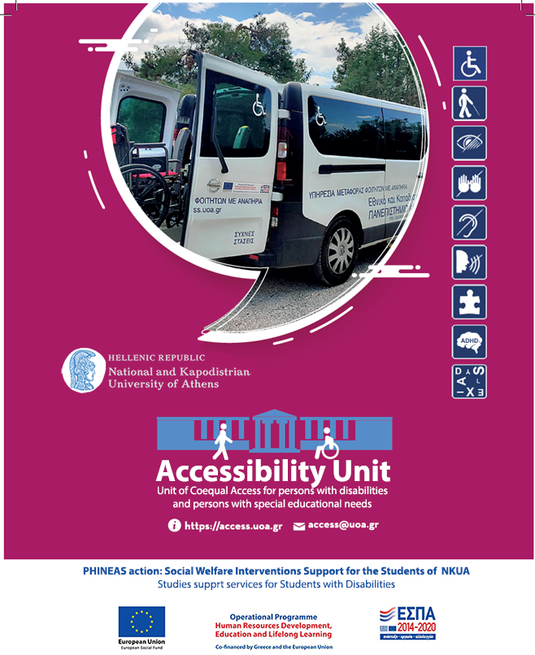

Service recipients of the Accessibility Unit
Recipients of the services provided by the Accessibility Unit are the members of the university community of the National and Kapodistrian University of Athens (NKUA) who have a diagnosis certificate issued by an official/state entity or healthcare provider for:
- sensory disability,
- motor disability,
- learning disability/dyslexia,
- pervasive neurodevelopmental disorders / autism / Asperger,
- severe disease,
- severe psychosocial problems,
who from now on will be referred to as “persons with disabilities or/and special educational needs.”

Coequal Access
The mission of the Accessibility Unite of the NKUA is to actively realize coequal access to academic studies for students with different abilities and needs, through built environmental modifications, Assistive Technologies and access services.
The basic requirements of the students with disabilities include:
- access to interpersonal communication with the members of the academic community,
- access to the built environment of the university,
- access to the educational material (printed or electronic),
- access to the blackboard and the presentations in the classrooms,
- access in keeping notes, course projects, and written examinations, and
- access to information, Internet content and Information and Technology applications.

Infrastructure of the of the Accessibility Unit
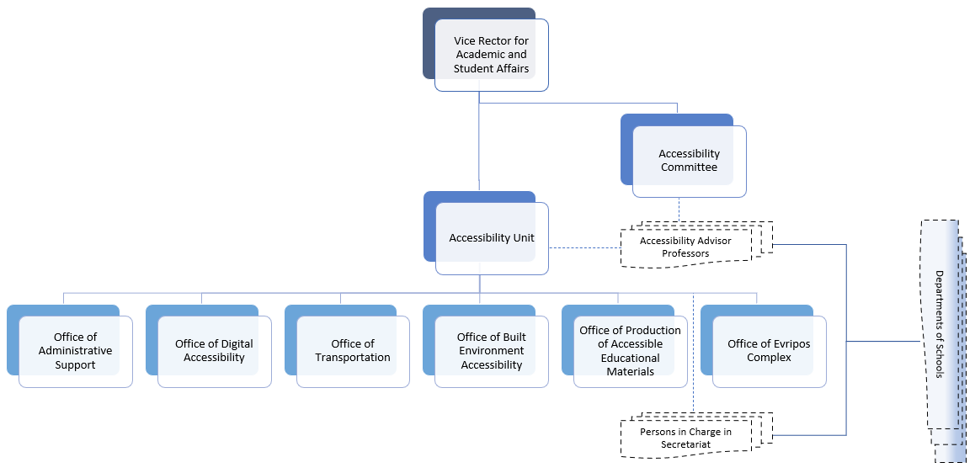
Accessibility Advisor Professor (and his/her Deputy) has been appointed in each Academic Department of the NKUA in order to support students with disabilities or/and special educational needs. The Accessibility Advisor Professor is the connecting link between the students and the teaching staff.
Person in Charge in Secretariat (and his/her Deputy) has been appointed in each Academic Department Secretariat of NKUA to attend to students with disabilities or/and special educational needs. They can be contacted by phone or e-mail.

E-Accessibility
Registration of limitations and restrictions: in order to receive services from the Accessibility Unit, to collaborate with the Accessibility Advisor Professor of their Department/Faculty, and to get reasonable accommodations for their participation in classes/labs/clinics and in exams, students with disabilities or/and special educational needs must fill in the Student’s Activity and Participation Restrictions’ Registration Form (ReF).
Abilities Assessment: based on the type and degree of disability, the abilities of the students and the academic tasks they must accomplish, it is possible to identify the potential obstacles they are expected to face during their academic studies. Next, the e-Accessibility Department applies international good practices and protocols as well as special laboratory tests to preselect the appropriate Assistive Technologies.
Individual Assistive Technologies: a customized technology solution is suggested to students with disabilities, technical support is provided for its composition, and the procurement of the corresponding equipment is facilitated.
The Free AT Software Inventory ATHENA and mobile ATHENA (https://access.uoa.gr/ATHENA/eng/pages/home ) aim to inform and provide persons with disabilities, their facilitators as well the professionals of the domain, with the available costless Assistive Technology (AT) solutions (Open Source or Freeware).
Accessible Library Workstations: allow students with partial or total vision loss, upper extremity motor impairments, dyslexia or hearing loss access to the NKUA library collections, Internet services, as well as common office automation applications.
Video Relay Service: provides students who are deaf or hard-of-hearing (users of Greek Sign Language (GSL)) and students with speech disability or severe dysarthria remote interpersonal communication in real-time with fellow students, faculty members/members of the teaching staff and the administrative staff of the NKUA.
Accessibility Support Voluntary Service: coordinates the systematic, discrete, and safe support of students with disabilities or/and special educational needs in matters related to their studies by properly trained volunteer-students.
Internet Accessibility: provides expertise on digital Internet accessibility and conducts accessibility audits of the University’s websites.
Publicity: makes the services of the Accessibility Unit known to anyone interested through an accessible website (https://access.uoa.gr/) in Greek and English languages, a Greek Facebook page called «Μονάδα Προσβασιμότητα του ΕΚΠΑ» and a YouTube channel named “Accessibility Unit of NKUA.”

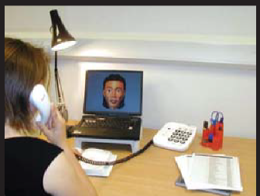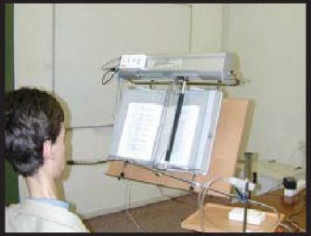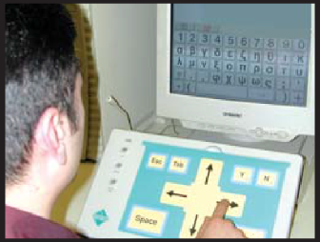

Transportation Service
The Accessibility Unit has special vehicles for the transportation of students with disabilities from their residence to the University premises and back. Priority of service is given to students who use the wheelchair or those with severe motor disabilities.

Production of Accessible Educational Material
The Accessibility Unit operates the online integrated service system ERMOFILOS (https://ermofilos.uoa.gr) for the production and distribution of accessible educational material, which supports all phases of converting and making academic textbooks available in different accessible digital formats for students with print disabilities. The system is addressed to all parties involved (students with print disabilities, publishers & authors of educational materials, Accessibility Unit’s staff who produce accessible educational materials, volunteers), ensuring, at the same time, the protection of the authors' copyrights. In addition, the Accessibility Unit produces and provides both short and detailed instructions for the creation of accessible educational material and accessible presentations to the teaching staff of the University.

Built Environment Accessibility
The Accessibility Unit undertakes the identification and/or recording of obstacles, problems and observations regarding the physical access of disabled people in the built environment of the University, concerning, for example, haptic signage of buildings for people with vision loss, handrails on stairs, spacious lifts with audible and braille signage, ramps, wheelchair lifts, accessible toilets and disabled parking spaces. The Unit drafts proposals for modifications to structural plans of existing and new buildings, so that they meet accessibility specifications based on current legislation. The Unit cooperates with the Technical Service of NKUA, which implements the physical accessibility. The Accessibility Unit also provides training for accompanying people with vision loss and wheelchair users.

Contact
access@uoa.gr
https://access.uoa.gr
- Building of the Department of Informatics and Telecommunications, Ground floor, University Campus, Ilisia, 15784 Athens, Greece
Tel. +30 210 7275687, 210 7275183, 210 7275130
- Evripou Complex,
34400 Psachna, Euboea
Tel. +30 22280 21808
June 2023

